CSA1717-ARTIFICIAL INTELLIGENCE
PRACTICAL LAB EXPERIMENTS
NIHARIKA PREEJESH (192524506)
PROGRAM 2: 8-PUZZLE PROBLEM
Aim
The aim of this experiment is to solve the 8-Puzzle Problem using the Breadth First Search (BFS) algorithm
Objective
To arrange the tiles in the correct order by moving the blank space.
Algorithm
Algorithm: EightPuzzleBFS()
Step 1: Start.
Step 2: Define the initial state and the goal state of the puzzle.
Step 3: Create an empty queue.
Step 4: Insert the initial state into the queue.
Step 5: Create an empty visited set.
Step 6: Repeat until the queue becomes empty.
Remove the front state from the queue.
If the current state is already visited,
Continue with the next state.
Mark the current state as visited.
If the current state is equal to the goal state,
Display the solution path.
Stop.
Locate the blank tile (0).
Generate all valid neighboring states by moving
the blank tile Up, Down, Left or Right.
Insert every unvisited neighboring state into the queue.
Step 7: If no solution exists,
Display "No Solution Found."
Step 8: Stop.
Source Code
from collections import deque
# Initial state
initial = (
(1, 2, 3),
(4, 0, 6),
(7, 5, 8)
)
# Goal state
goal = (
(1, 2, 3),
(4, 5, 6),
(7, 8, 0)
)
def find_blank(state):
for i in range(3):
for j in range(3):
if state[i][j] == 0:
return i, j
def get_neighbors(state):
neighbors = []
x, y = find_blank(state)
directions = [(-1,0),(1,0),(0,-1),(0,1)]
for dx, dy in directions:
nx, ny = x + dx, y + dy
if 0 <= nx < 3 and 0 <= ny < 3:
new_state = [list(row) for row in state]
new_state[x][y], new_state[nx][ny] = new_state[nx][ny], new_state[x][y]
neighbors.append(tuple(tuple(row) for row in new_state))
return neighbors
def bfs(initial, goal):
queue = deque()
queue.append((initial, []))
visited = set()
while queue:
state, path = queue.popleft()
if state in visited:
continue
visited.add(state)
path = path + [state]
if state == goal:
return path
for neighbor in get_neighbors(state):
if neighbor not in visited:
queue.append((neighbor, path))
return None
solution = bfs(initial, goal)
print("Steps to solve the 8 Puzzle:\n")
step = 1
for state in solution:
print("Step", step)
for row in state:
for value in row:
if value == 0:
print("_", end=" ")
else:
print(value, end=" ")
print()
print()
step += 1
Flowchart
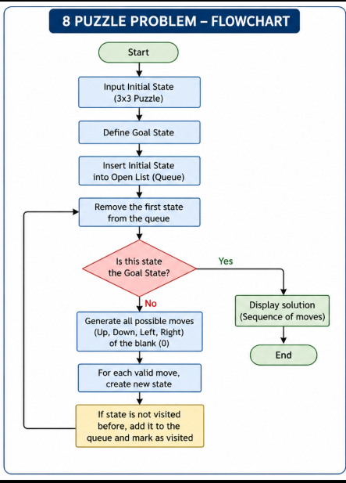
Output

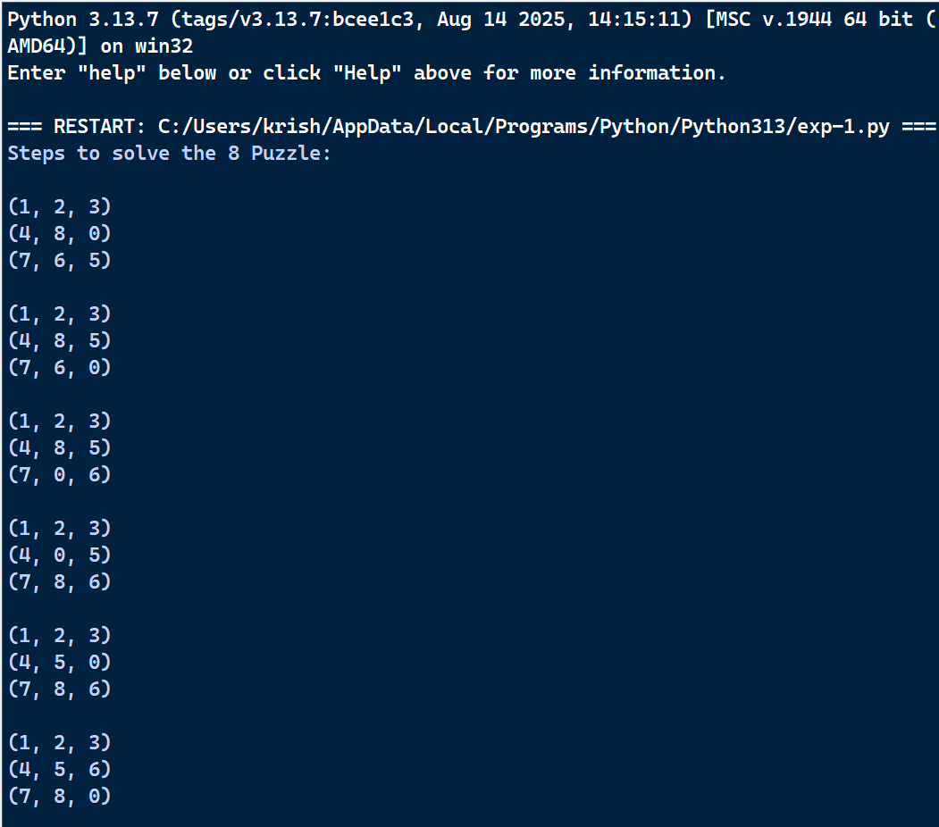
Result
Therefore, the Python program to solve the 8-Puzzle problem was executed successfully.

